The Unlocked Brain

John 20:19-31

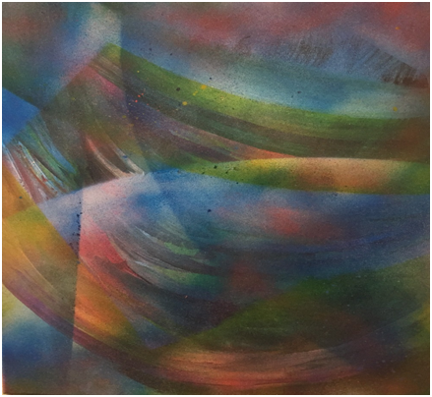

Look at the image. Tell me what you see.

Our brains are amazing vehicles for informing us of the world around us, but they can also limit us and impede us when we believe that what we see defines everything that’s real and true or that what we see defines the entirety of the universe. Can we truly know based on only our sensory experience? Or is there something more, another kind of knowing, that lies outside of our empirical knowledge? Christians believe there is. In fact, most people believe there is, but yet, we insist that what we see and know is the naked truth.

What is this beautiful image?

It’s a human eye.

Intricate and beautifully made, the eye serves as our refractor for both color and truth. Our eyes help us make sense of who and where we are in our scheme of existence.

But when we change our view, our images change, and so does our knowledge and truth.

Pull back the lens, and you see a “big picture” you may have not known was there, as well as how the object of your vision fits into the relational scheme of things. Draw in closer, and you see intricacies you missed in the larger view. Our eyes send those pictures, snap shots if you will, to our “knowledge processor and memory keeper” –our brain.

In a sense, our eyes are feeding our brains a spoonful of knowledge, a spliced image of truth that we then interpret according to what we already know.

The eye is nothing compared to the synthesizer we call the brain!

The right side of your brain is your relational side. It sees the world holistically, in terms of relationality. It makes connections and processes our emotions. With this side of our brain, we see ourselves connected to the universe, to the energy around us, and to God. This is the side that is creative, sees beauty, and loves.

The left side of our brain is more analytical. It sees you as an individual, a separate being from the rest of the created world. It puts images, feelings, and memories into categories so that we can understand them and make sense of our world. It is a categorizer and analyzer, the knowledge and order-making part of us.

Our brains were designed by God this way so that we can both know ourselves as individuals but also know God, others, and our world, love them, and see them as beautiful (connection and relationship, covenant, and kingdom). The two halves of our brain work together. They are connected by a series of neuron fibers that transmit and share information and images.

The human body is amazing! And it’s designed to help us both live well in our world, to know what we experience and see and be in relationship with God, to have faith and know that what we see and experience is not all that there is. But sometimes, our brains can get into what I call “lockdown mode.” Stress, grief, tragedy, too much focus on logic and not enough on relationships –these can cause our brains to favor the left side of our brain. We become self-reliant and closed off to our emotions, the beauty in the world, and faith. We start to question anything that we cannot experience first-hand with our senses. We protect ourselves by believing only in what we can see. We go into “lockdown.”

In a sense, this is what happened to Jesus’ disciples after his death. They went into lockdown mode. They were traumatized by the death of their leader, rabbi, and teacher. To them, the movement and the mission had failed, ended, cease to exist. All their hopes, dreams, expectations, faith in Jesus’ projections for the future seemed suddenly like pipe dreams, and they began to wonder what they could have been thinking, taking the risks they did. Fear took over. And their fears were valid. Both the religious elite and the Romans would gladly kill any disciples of Jesus, they feared. Danger lurked in and around Jerusalem. They were afraid. And so they hid. They locked themselves inside a house in Jerusalem, sat shiva for their friend, grieved, mourned, and wondered what to do next. Lockdown. Literally and spiritually.

It’s no mistake that Jesus appears to the disciples behind closed doors, within locked rooms. Jesus needed not only to enter their house. He needed to enter back into their hearts. He needed to restore their faith.

Only faith would release them from their immobilization, their deep-freeze. Only faith could propel them forward again into hope and into mission, so that Jesus’ movement could continue.

He would first need to break through their grief, their doubts, their despair, and the “logic” that told them, they had been foolish, and they needed to think practically and rely only on their own judgments, look out for their lives –literally.

It’s no mistake that Thomas needs to “literally” feel the wounds on Jesus’ body. His mind, like the others, has been in lock down. And he needs to be released.

There is more than one “resurrection” in the Easter story. This is another. It is a story in which Jesus resurrects the faith, the hope, and the joy of his disciples. He lifts them from the depths of grief and despair and sets them back upon their feet, so to speak. He makes them “whole” again by allowing them to process that he is not dead but alive, that the mission has not ended, but has only just begun.

Even after this visitation, it would take the disciples multiple encounters with Jesus before they would be ready for the Holy Spirit’s mission-giving breath at Pentecost. Each time, he would continue to unlock their minds, unfreeze their hearts, unhinge their fear, and restore their faith.

Today, we too live in times and through difficulties that can freeze our hearts and lock down our minds in fear and worry. We call it survival mode. We try our best in these times just to get by. We do so by trying to secure ourselves from hurt, pain, trauma, and grief, and in the process, we lock people out. And we lock God out.

This morning, I invite you all to open up your minds to allow Jesus to restore your faith. Relax your mind, close your eyes, and let your fears and worries go. Allow the Holy Spirit of Christ to enter into your mind and heart and to unlock the grief and pain that binds you, to release the hurt and fear that paralyzes you, to restore your faith in yourself, in God, and in others.

For Jesus is King of resurrections. He is risen. And he can raise you too, not just in your death, but in your living.

May God bless you and keep you, and may Christ live within your heart, keeping you free of fear and doubt, and endowing you with faith to move mountains and love to move others.